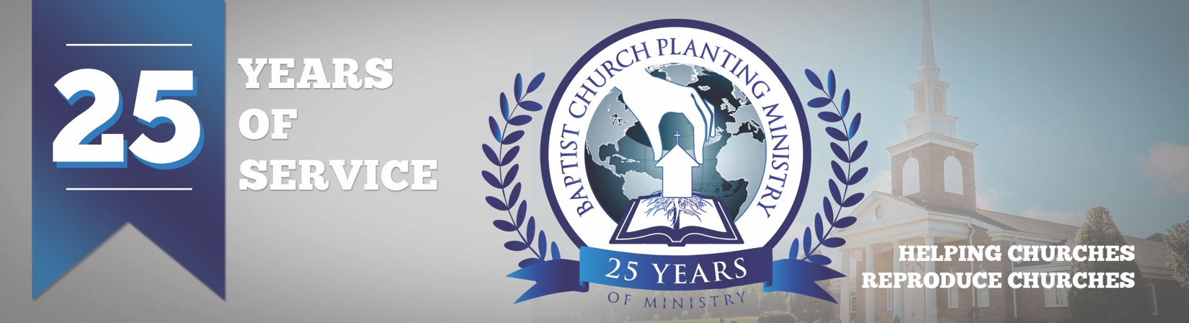

March 2018

We love babies, especially baby churches! The Lord granted another birth of a church, this time in Florida. The Get Acquainted Meetings for the new church in South Naples took place February 25-March 5. It was good to see at least nine preachers attend representing several area churches including Emmanuel Baptist in Ft. Myers, Gospel Baptist in Bonita Springs, Victory Baptist in Port Charlotte, Bethel BC in North Port, and Winkler Road BC in Fort Myers. These local churches brought members to help serve in various areas and were a tremendous blessing. The preaching, special music, and fellowship throughout the week helped give credibility to the new pastor and also gave a sample of what the new church would be like. Pray for Pastor Jim Barker and for Bible Baptist Church as they continue to spread the gospel and reach the growing and needy area of South Naples.

Thank you for praying for the European church planting conference we held February 8 and 9 in Reggio Emilia Italy. Eight pastors attended including one from Slovenia and one from England. This was a conference to lay the groundwork for a Biblical philosophy of church planting. The pastors received it well. Missionary Brandon Cook was the host pastor and he was very excited and thankful. Lord willing, we will be helping him establish the church in 2019. I was able to preach to his small group of believers on Sunday and, on Tuesday night, one of the ladies received Christ as her savior! Just like we are seeing in other countries, pray for much fruit in Italy and for a surge of the churches to reproduce churches.

We are just five months away from BCPM’s 25th anniversary service and we are excited for this historic occasion. We will be recognizing all the church planters and reproducing pastors who have used BCPM. We will thank the Lord for how he has blessed the ministry in the past and also share what we believe the Lord will do in the future. It will be held at 7pm on July 31 at South Haven Baptist Church in Springfield, TN.

Thank you for your continued support! Your investment is making a difference in world-wide church planting. Please make note of the new US mailing address for BCPM. All US support and mail should be mailed to our new mailing address at PO Box 387 Greenbrier, TN 37073.

Advancing in Christ,

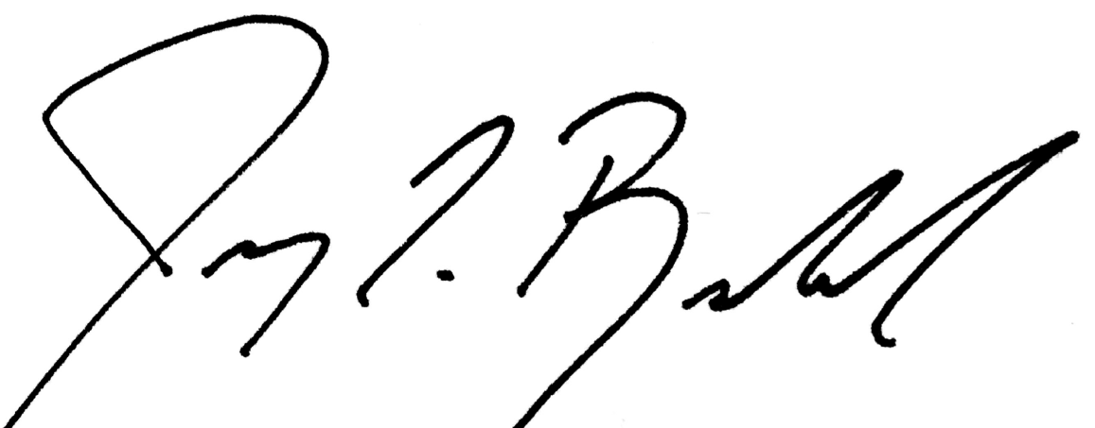

Jeremy Rowland,
General Director

