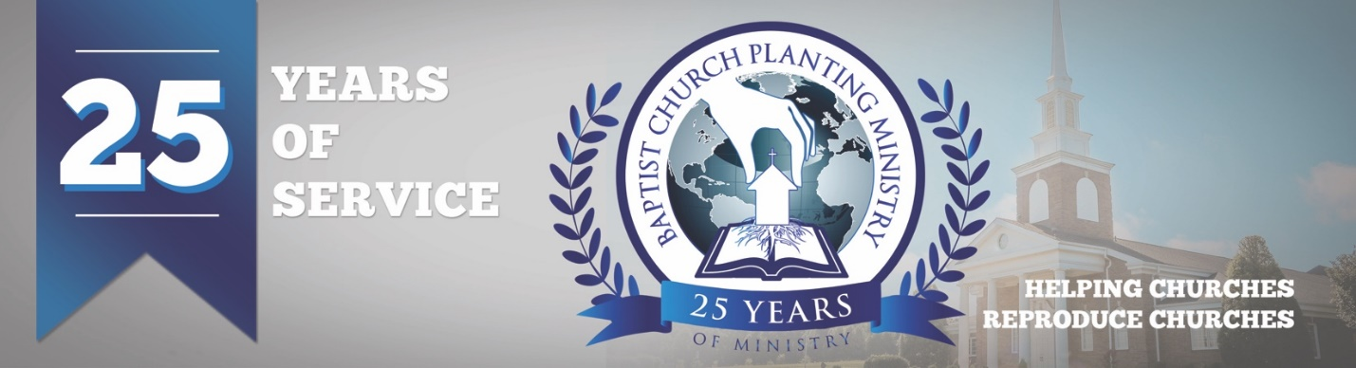

July 2018

We are just a few weeks from celebrating BCPM’s 25th-anniversary with a special banquet and service, and we have had a wonderful response from pastors who plan to attend. We will be recognizing all the church planters and reproducing pastors who have used BCPM. We will also thank the Lord for what He has done and prayerfully will do as we advance church planting worldwide. The special event will be held at 7 pm on Tuesday, July 31 at South Haven Baptist Church in Springfield, TN. We would love to see you there so please email one of our staff or sign up online.

We are also excited to host our first “Pre-plant Conference” on August 1 and 2 in conjunction with the 25th-anniversary in Springfield, TN. The "Pre-plant Conference" will be a time of instruction and encouragement and is designed to help the church planter and his wife prepare for the uniquenesses of church planting. All church planters are invited to attend and can sign-up online.

The Lord is at work advancing the gospel into needy areas. We are presently working on church plants in Arizona, Ohio, Massachusetts, and in the countries of Portugal and Italy. We will keep you informed with the details in future prayer letters. Thank you for prayerfully and financially partnering with BCPM. It is a tremendous investment as we help reproduce churches throughout the world.

Advancing in Christ,

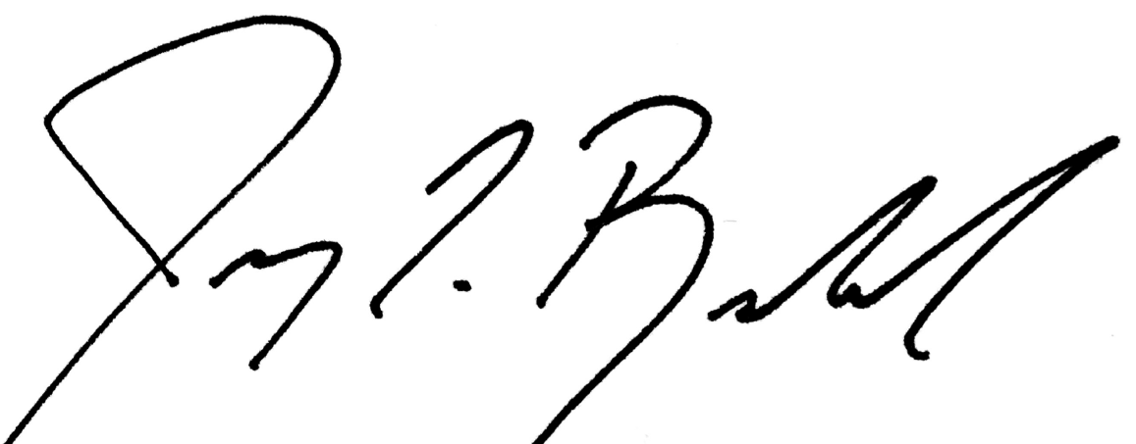

Jeremy Rowland,
General Director

