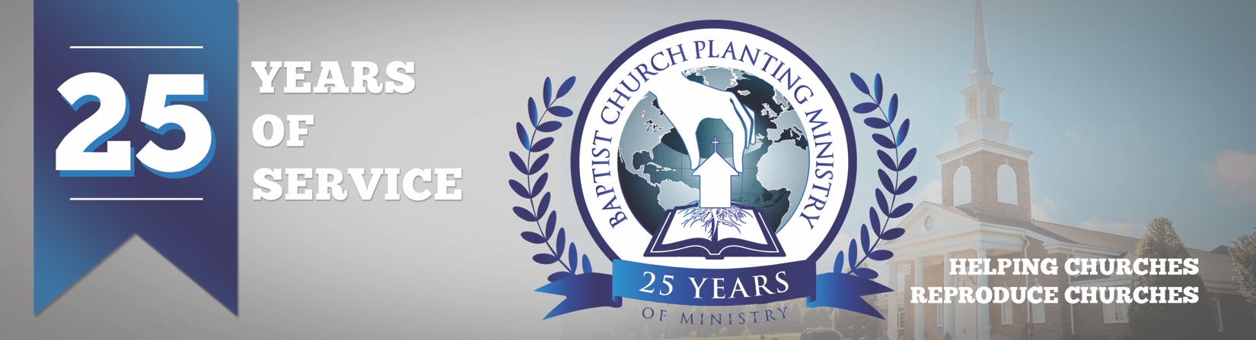

August 2018

On July 31 BCPM celebrated twenty-five years of ministry. The Lord blessed with a wonderful time of praising Him for what He has done! During the banquet, pastors gave testimonies of how BCPM has helped with their church plants. During the night service, we recognized all the pastors and church planters attending, showed videos, honored Mrs. Jessup, and challenged those attending to pray as we continue to advance church planting. The Lord truly blessed as we reflected and refocused on what He has and will do through BCPM. A special thank you goes to South Haven Baptist Church and the staff for all that they did to host this special time.

We were also excited to host our first “Pre-plant Conference” on August 1 and 2 in conjunction with the 25th-anniversary. The "Pre-plant Conference" was a time of instruction and encouragement and was designed to help the church planter and his wife prepare for the uniqueness of church planting. We had a great time of encouragement, instruction, and enrichment.

We need your prayers as we now focus on what the Lord has for us in the future. We are presently working on church plants in Arizona, Ohio, Massachusetts, and in the countries of Portugal and Italy. We will keep you informed with the details in future prayer letters. Thank you for prayerfully and financially partnering with BCPM. It is a tremendous investment as we help reproduce churches throughout the world.

Advancing in Christ,

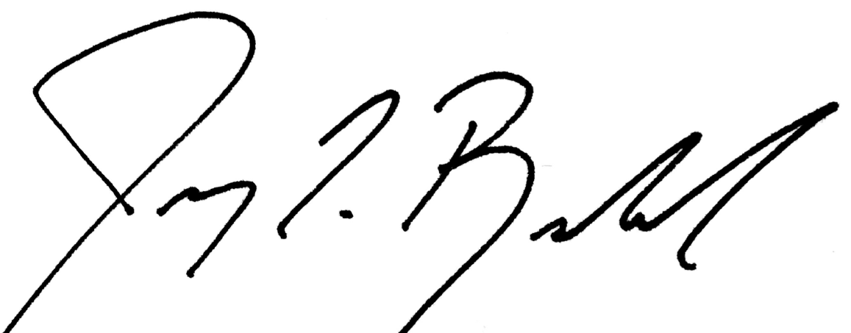

Jeremy Rowland,
General Director

