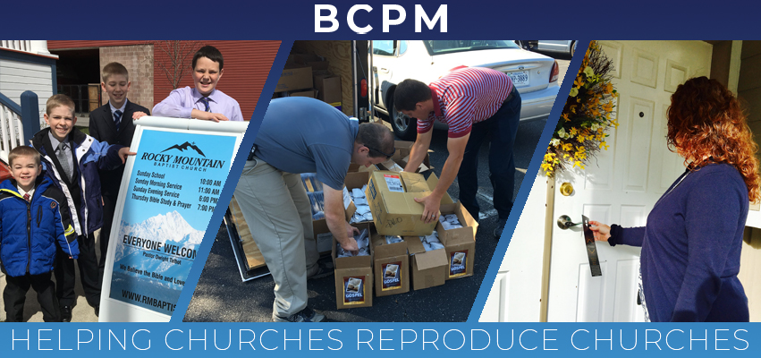

Aug 1, 2019

Happy 26th Anniversary!

Thank you for supporting a ministry that has been so blessed of the Lord for 26 years! It is amazing to look back and see God's hand, protection, and provision.

- 174 Churches birthed (54 were foreign)
- 92% survived well past the first two critical years
- 2,600000 homes reached with John and Roman booklets
- Over 4,500 people are saved yearly
- Over $4,300,000 yearly given to missions

As we look ahead, we are asking the Lord to continue to bless the efforts of reaching new communities with the gospel of Jesus Christ and establishing local churches. North America and the world is in desperate need and we are doing all we can to advance church planting. Please join us in prayer as we help churches reproduce churches all over the world.

Advancing in Christ,

Jeremy Rowland,
General Director
BCPM.org

