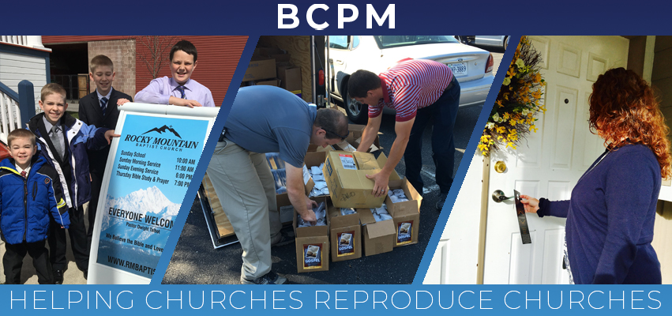

October 2019

We praise the Lord for how He recently blessed the Sarnia, Ontario, church plant. The Get Acquainted Meetings that took place in September were well attended with over thirty guests from the community. It was also good to see twenty-two preachers attend and show their support for the new work. On the opening Sunday, there were sixty-one in attendance with thirty-one first-time guests. Pray for Pastor Bruce Cook and Graceway Baptist Church as they continue to reach Sarnia with the gospel.

The attention now turns to the church plant in Leawood, KS, with the Get Acquainted Meetings scheduled for October 20-24. The reproducing church is South Knollwood Baptist, under the leadership of Pastor Jeremiah Metsinger, and the church planter is Brother Keith Drinkard. Please pray for the evangelistic efforts as rain has caused delays. Several churches are making special efforts to make sure the area is saturated with the John and Romans, invites, and other gospel literature. Pray for souls to be reached and for God to build His church in Leawood.

We are pleased to announce "BCPM Planting Point," a weekly podcast to help encourage Independent Baptists to plant churches. "BCPM Planting Point" podcasts have helpful sessions and interviews from experienced church planters and reproducing pastors. You can find “BCPM Planting Point” on Apple I tunes, Google Play, Spotify, Stitcher, Soundcloud, and Speaker Podcast Radio. We hope this will encourage and strengthen the church planting efforts.

Thank you for your investment in BCPM! Your prayer and financial support is a tremendous help in making an impact through church planting.

Advancing in Christ,
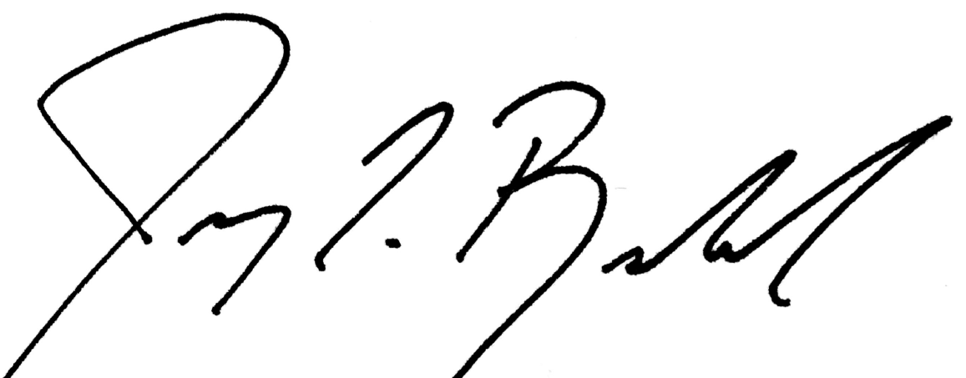

Jeremy Rowland, General Director

